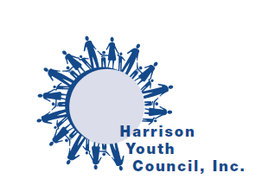

Dear Parent:

Early work experience can help youth people learn skills that are vital for success and happiness. The Harrison Youth Council offers support to eligible registrants so that they may develop good habits and form a set of work values which will eventually become their work ethic – one that will serve them and the community as well.

This parent consent form must be signed by each parent and returned to the YES Coordinator with the student’s application.

We look forward to working with your son/daughter.

Parental Consent

I understand that:
- YES is a program of Harrison Youth Council, a non-profit organization, which furnishes students, age 14 and older, seeking employment with the names of prospective employers.
- YES makes no investigation of prospective employers or places of employment. I will satisfy myself that the employment offered to my minor child will not be detrimental to his/her health, safety or morals. I will hold the agency harmless from any claims, losses, costs, or suits for injuries, death or damages which may arise from the employment of my minor child, either with respect to my child or a third person
- New York State Law requires all teenagers under 18, including high school graduates who work in commercial establishments to obtain working papers.
- I authorize YES to furnish my child with the names of prospective employers.

Parent or Guardian’s Signature:_____________________________________

Parents or Guardian Email:_________________________________________

Parent or Guardian Phone:_________________________________________

Date:_________________________________

